NORSI-PIMS Course papers: General Principles and Evaluation
One of the goals of NORSI-PIMS is the development of effective technical writing skills. To help you become an accomplished writer, you will prepare academic papers based upon the literature in each course. You are certainly allowed to, and even expected to, draw on literature outside the course curriculum, but your primary focus should be on situating the course literature in relation to your research interest. Secondary focus should be on situating the course literature in the larger body of literature; this however is less important in your early course papers than in your later course papers. After you have a more clearly defined research topic and a better understanding of research methodology, we will revise and extend the general principles for course papers.
The process of writing these papers will help you develop and perfect the writing skills that will benefit you when you seek to publish your research in academic journals. Written and oral communication skills are probably the most universal qualities sought by future employers both in academia and industry. You alone are responsible for developing such skills to a high level, and writing the NORSI-PIMS course papers provides you with an arena to hone those skills.

- General Purpose
In each course paper you should review the literature of the course (both sessions), demonstrate mastery of this body of literature. This means two things:
  - Demonstrate your ability to compare and discuss theory, point to weaknesses, contradictions as well as strengths and important contributions. You are free to use other literature to support or contradict the course literature, but keep in mind that your primary purpose is to demonstrate your understanding and mastery of the course literature.
  - Demonstrate your ability to select the parts of the literature that is particularly pertinent to your research interest and use this as a lever to show how the literature informs the area of your research interest, and subsequently our research questions.

- Formatting and Style
Please use line spacing 1,5, Times New Roman 12 font, and 2,5 cm margins. Follow the standards laid out in the Publication Manual of the American Psychological Association http://www.apastyle.org/manual/index.aspx when you write all your papers. Here are some useful resources http://www.apastyle.org/ including tutorials. Citing, quoting and referencing correctly are important in academic writing.

- Tips and Resources on Writing
There are many excellent resources on writing out there.
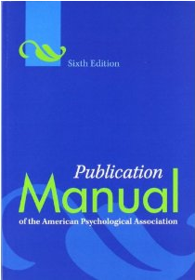
Here is the publication manual of the American Psychological Association. This presents the standard academic format, at least in the social sciences, in a clear and easy to access manner.

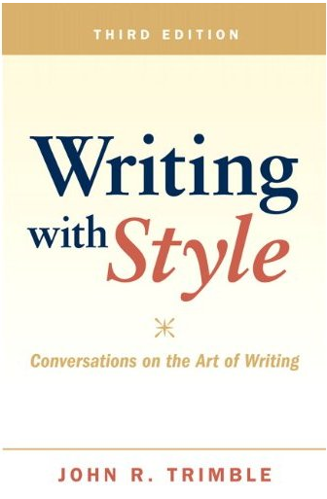
John Trimble’s book «Writing with Style» is one that has stood the test of time. This book is great to get you started, solid on the basics of writing and full of practical tips. It is however, not a book on academic writing.

One important thing to always remember is that re-writing (that is editing, tweaking and adjusting, and perhaps most importantly, deleting poor text) is but to a few, what good writing is all about. At the beginning of this career, Harvard professor, John Kotter, lamented to management guru Peter Drucker that he often had to discard pages and pages of text. “Ah, but that is immense progress” was the immediate response he drew from Drucker. Harry Shaw, in “Errors in English and Ways to Correct Them,” says, "There is no such thing as good writing. There is only good rewriting." Science fiction novelist Michael Crichton agrees: "Books are not written—they're rewritten." In short, if your first draft is no good, take courage, it will get better.
We find that it is important to get things on paper. I wholeheartedly agree with Harry Wolcott who claims that writing is a form of thinking, and that it therefore is impossible to start writing too early. But, by extension, this also means that some of your initial drafts will be half-baked, some will be outright bad, and some will be brilliant. It is the nature of the beast. Our advice is to quickly discard the bad, work on the half-baked, and celebrate (and perfect) the brilliant.
Be diligent about developing and perfecting your writing skills. Observe yourself writing. Over time I think you will find that at certain times (perhaps in the afternoon) you are creative and can generate text. If so, then make a note of these times and try to exploit them to the fullest. Don’t stop writing. Generate text. Don’t stop to evaluate or tweak what you have written, just keep writing. Then perhaps, at other times (perhaps early in the morning) you are in a more critical mood and find it difficult to write. Well, this is probably a good time for you to take a critical look at the text you already have generated. Spend the time when you critical mind works the best on discarding poor text, rewriting mediocre text and on polishing and perfecting final sections. In this way you’ll be most effective and efficient with your writing time, and you’ll be a better writer.
One final tip, and this is going to sound a bit nuts, but it really works. When you have sections that you think are starting to look pretty good, or nearing finished. Stand up. Read your text out loud. And, I mean loud; not whispering, not talking to yourself. Read, like you were talking to someone across the room. Seriously! We can almost promise that if you actually do this with a full page of text that you have written yourself and that you think is finished; you will never stop doing this. It will surprise you to hear your own text out loud. Things that you have been over many times and that you think is fine will sound odd to you and will need to be tweaked and rewritten. The simple truth is that we can actually hear things that we can’t see on paper.

- Evaluation
Below are some elements that we will look for when we evaluate your papers.
- Abstract (7,5%)
  - 150 word or less summary of your paper.
- Introduction and purpose (10%)
  - How you introduce and set-up the purpose of your paper.
- Literature review (65%)
  - How well you review the literature and relate it to your topic. Here you should demonstrate mastery though how you (re)structure the literature. You are not only expected to review the literature, but also to find your own voice. That is, comparing and contrasting the literature, and making coherent (theoretical) arguments.
- Summary and conclusion (7,5%)
- Formal elements (10%)
  - Formatting, grammar, references, title page, running head, etc. 10%

The values (percentages) above cannot be but approximations, as it is the whole that matters. But, they are included to give you a better idea of what we look for in these papers.

Alf Steinar Sætre
Arild Aspelund
Elsebeth Holmen
Endre Sjøvold

